## GATEBOX: DETAILED ELECTRONICS PARTS LIST

By Shafeeq Rabbani

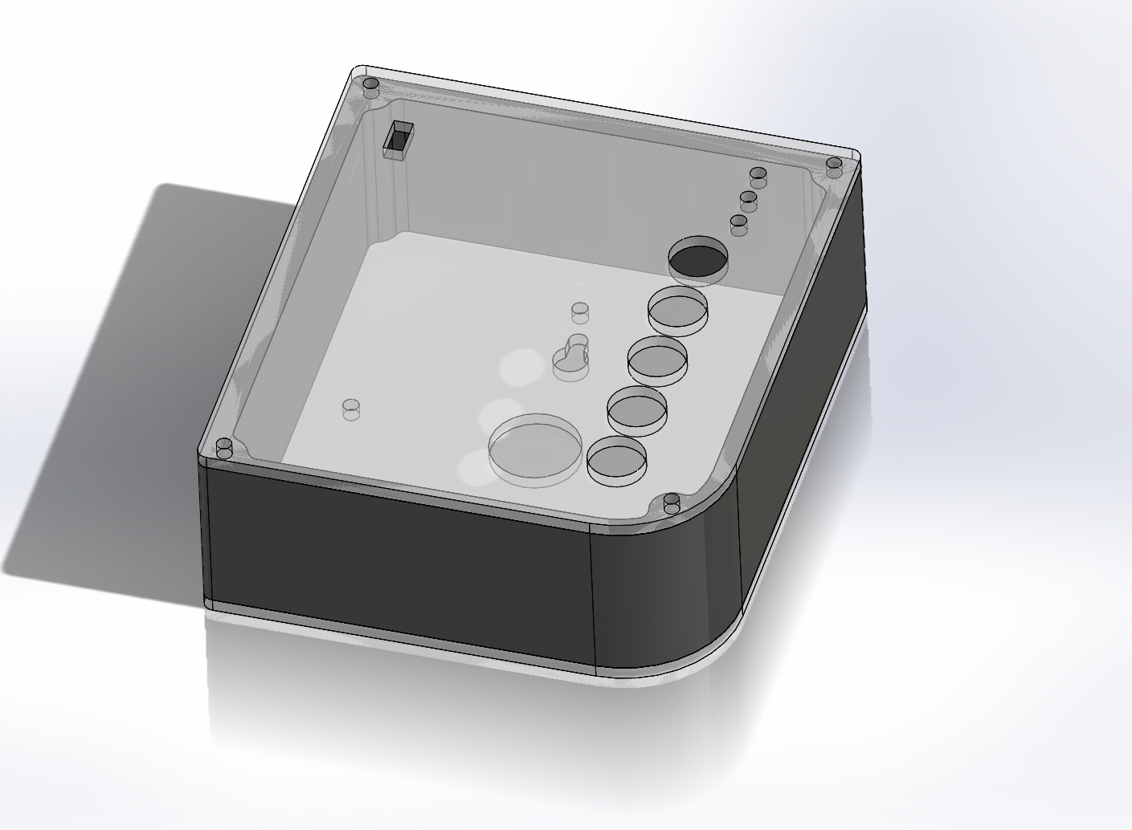

Contents

GATEBOX: DETAILED ELECTRONICS PARTS LIST 1

Introduction 2

Custom Arduino Board + GateBox Accessories 3

nRF8001 BLE Board 5

## Introduction

As this approach involves creating everything from scratch and printing it all on a single PCB. Currently, there isn’t a complete version of the circuit. There is one that is almost complete: Would appreciate it if someone could replace the two solid state relays in the “PCB with nRF/Dual Relay” folder, with 4 mechanical relays (as shown in PCB V7 board.PNG and PCB V7 Schematic.PNG in Simplified Schematic folder) and re-route all the wires and push the .brd and .sch files. The Detailed Schematic/nRF8001 folder also contains .sch and .brd files of the nRF8001 chip from Nordic Semiconductors and Adafruit, the manufacturers of the nRF8001 chip and the Bluetooth Low Energy module respectively.

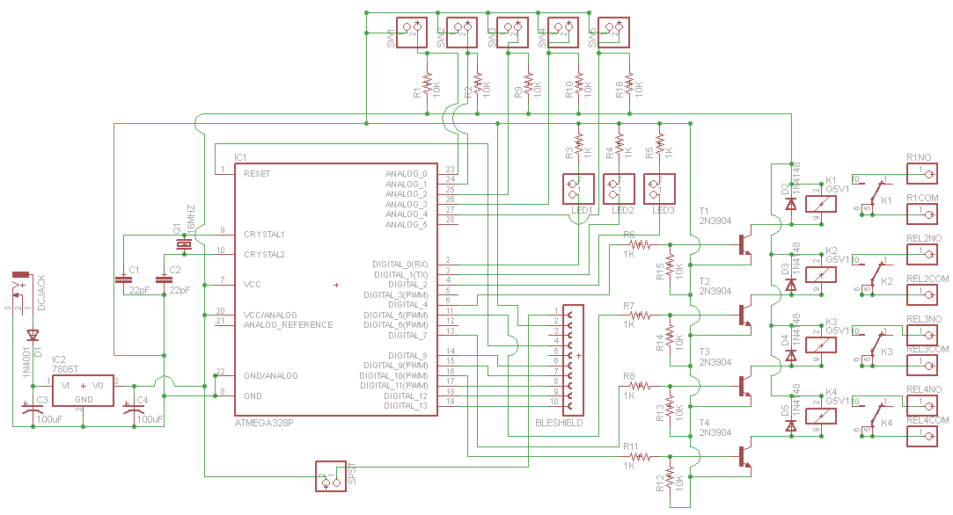

## Custom Arduino Board + GateBox Accessories

As the GateBox device is expected to be up and running for 24/7, you will require a 5V DC power supply that can power the Arduino UNO.

|  |  |  |  |  |  |  |  |
| --- | --- | --- | --- | --- | --- | --- | --- |
| Part | Digikey/ Element14 Part No. | | Manufacturer Part No. | Quantity | Picture | Cost | |
| Atmega 328p Microcontroller | 68T2944 | | ATMEGA328P-PU | 1 | http://shop.emscdn.com/catalog/components/semi/mcu/atmega328p/imglrg/1.jpg | $3.24 | |
| 16 MHz Crystal Oscillator | 18C1481 | | XT9S20ANA16M | 1 | http://orzparts.com/images/16MHZ.jpg | $0.338 | |
| 28 pin DIP IC Socket | 34P8056 | | 4828-3004-CP | 1 | http://media.digikey.com/photos/3M%20Photos/4828-3004-CP.jpg | $0.503 | |
| Rectifier Diode 1A, 50V | 10M8464 | | 1N4001 | 1 | http://media.digikey.com/photos/Fairchild%20Semi%20Photos/261-DO-41.jpg | $0.113 | |
| LM-7805-CT Linear Voltage Regulator | MC7805CTG | | MC7805CT-BPMS-ND | 1 | http://www.learningaboutelectronics.com/images/LM7805.jpg | $0.487 | |
| Terminal blocks | ED1623-ND | | ED500/2DS | 4 | ED500/2DS On Shore Technology Inc | ED1623-ND DigiKey Electronics | 0.85 | |
| 2.1mm DC Barrel Jack | CP-037A-ND | | PJ-037A | 1 | DC Barrel Power Jack/Connector | $1.23 | |
| 100uF, 25V Aluminum Electrolytic Capacitor | 39T8695 | | 25YXH100MEFC6.3X11 | 2 | http://ecx.images-amazon.com/images/I/31IHAvewH7L._SX342_.jpg | $0.075 | |
| 22 pF, 50 V Ceramic Capacitors | BC1034TR-ND | | K220J15C0GF5TH5 | 2 | http://www.famosastudio.com/image/cache/data/Ceramic%20Capacitor%2022pF-500x500.jpg | $0.34 | |
| 3mm LED, FWD V= 2.1V  FWD I= 20mA | 94T8843 | | 703-0087 | 3 | http://www.custobots.com/sites/default/files/imagecache/product_full/products/Solarbotics-redLED.gif | $0.184 | |
| 10K Ω Resistor, 1W, 5% | 95W5667 | | CFR100J10K | 8 | http://i00.i.aliimg.com/wsphoto/v1/724668692/Carbon-film-resistor-10kOhm-1w-5-Tolerance-100pcs-free-shipping-of-China-POST.jpg_350x350.jpg | $0.18 | |
| 1K Ω Resistor, 1/4W, 5% | 25M8365 | | CBT25J1K0 | 7 | http://www.digchip.com/datasheets/photos/1838/CFR-25JB-1K0.jpg | $0.32 | |
| 6 Pin Male Header | 609-3263-ND | | 68000-406HLF | 4 | 68000-406HLF FCI | 609-3263-ND DigiKey Electronics | $0.24 | |
| G5V-1-DC Low Signal Relay | | Z773-ND | G5V-1-DC5 | 4 | G5V-1-DC5 Omron Electronics Inc-EMC Div | Z773-ND DigiKey Electronics | 2.77 | |
| SPDT Sliding Switch | | CKN9565-ND | OS102011MS2QN1 | 1 | OS102011MS2QN1 C&K Components | CKN9565-ND DigiKey Electronics | 0.54 | |
| DIODE GEN PURP | | 1N4148TACT-ND | 1N4148TA | 4 | 1N4148TA Fairchild Semiconductor | 1N4148TACT-ND DigiKey Electronics | 0.14 | |
| Transistor NPN | | 2N3904FS-ND | 2N3904BU | 4 | 2N3904BU Fairchild Semiconductor | 2N3904FS-ND DigiKey Electronics | 0.26 | |
| SWITCH PUSH SPST-NO | | EG1900-ND | **RP3502ABLK** | 5 | RP3502ABLK E-Switch | EG1900-ND DigiKey Electronics | | 2.80 |

## nRF8001 BLE Board

|  |  |  |  |  |  |
| --- | --- | --- | --- | --- | --- |
| Part | Digikey/ Elfa Distrelec/ Element 14/ Mouser Part No. | Manufacturer Part No. | Quantity | Picture | Cost |
| BLUETOOTH LW ENERGY nRF 8001 | 1490-1026-ND | nRF8001-R2Q32-T | 1 | http://media.digikey.com/Renders/Nordic%20Semiconductor%20ASA/32-VFQFN%20Exposed%20Pad.jpg | $5.72 |
| Buffers & Line Drivers HEX HIGH-LOW LEVEL SHIFTER | 568-8150-1-ND | 74HC4050D,653 | 1 | NXP Semiconductors 74HC4050D,653 | $0.606 |
| Tantalum Capacitors Solid SMD 10uF | 718-1126-2-ND | 293D106X96R3A2TE3 | 2 | Vishay / Sprague 293D106X96R3A2TE3 | $0.229 |
| LDO Voltage Regulators High | 576-2980-2-ND | MIC5225-3.3YM5 TR | 1 | Micrel MIC5225-3.3YM5 TR | $1.28 |
| CERAMIC CAPACITOR 15PF 50V, C0G, 5%, 0402 | 38K1652 | GRM1555C1H150JZ01D | 4 | Vishay / Vitramon VJ0603A150JXACW1BC | $0.106 |
| CRYSTAL 32.768KHZ 12.5PF SMD | SE2415CT-ND | FC-255 32.7680K-A3 | 1 | FC-255 32.7680K-A3 EPSON | SE2415CT-ND DigiKey Electronics | $1.69 |
| Capacitor SMD 33 nF 25 VDC 0402 | 65-754-51 | GRM155R71E333KA88D | 1 | ???en.catalog.isa.productImage???: Capacitor SMD 33 nF 25 VDC 0402, GRM155R71E333KA88D | $ 0.683 |
| CAPACITOR, 0402 0.1NF 50V | 578095 | CM05CG101J50AH | 2 | http://in.element14.com/productimages/standard/en_GB/1458900-40.jpg | $1.00 |
| Capacitor SMD/SMT 0.1uF 25volts | 478-7868-1-ND | 04023C104KAT2A | 1 | http://uk.farnell.com/productimages/standard/en_GB/128823906-40.jpg | $0.471 |
| CAP, MLCC, X7R, 1NF, 50V, 0402 | 490-1303-1-ND | GRM155R71H102KA01D | 1 | http://in.element14.com/productimages/standard/en_GB/128823906-40.jpg | $0.368 |
| Ceramic Capacitors MLCC - SMD 10UF 6.3V 20% 0402 | 81-GRM155R60J106ME4D | GRM155R60J106ME44D | 1 | Murata Electronics GRM155R60J106ME44D | $0.444 |
| Capacitor, 1.5pF 50 V DC C0G Dielectric ±0.1pF SMD | 490-8087-1-ND | GJM1555C1H1R5BB01D | 1 | Murata 0402 GJM 1.5pF Ceramic Multilayer Capacitor, 50 V dc C0G Dielectric ±0.1pF SMD | $0.10 |
| Capacitors MLCC - SMD 0402 22pF 50V C0G 5% | 581-04025A220J | 04025A220JAT2A | 1 | AVX 04025A220JAT2A | $0.135 |
| Capacitors MLCC - SMD 0402 1.8pF 50V C0G +/-0.1pF | 81-GJM1555C1H1R8BB01 | GJM1555C1H1R8BB01D | 1 | Murata Electronics GJM1555C1H1R8BB01D | $0.283 |
| CAPACITOR, MLCC, 2.2NF, 50V, X7R, 0402 | 2310511 | MC0402B222J500CT | 1 | http://canada.newark.com/productimages/standard/en_US/5138054.jpg | $0.11 |
| RESISTOR, 10K, 0.063W, 1%, 0402, SMD | 541-10.0KLCT-ND | CRCW040210K0FKED | 1 | http://in.element14.com/productimages/standard/en_GB/1738888-40.jpg | $0.59 |
| RES SMD 22K OHM 0.1% 1/10W 0603 | P22KDBCT-ND | ERA-3AEB223V | 1 | ERA-3AEB223V Panasonic Electronic Components | P22KDBCT-ND DigiKey Electronics | $0.91 |
| EMI Filter Beads, Chips & Arrays Ferrite Chip Beads | 810-MMZ1608B121C | MMZ1608B121C | 1 | TDK MMZ1608B121C | $0.135 |
| 8.2nH SMD Inductor, SRF: 4.9GHz Q: 23 550mA dc 160mΩ Rdc | 810-MHQ1005P8N2JT | MHQ1005P8N2JT | 1 | TDK MHQ1005P Series 8.2 nH ±5% Ceramic Multilayer SMD Inductor, 0402 Case, SRF: 4.9GHz Q: 23 550mA dc 160mΩ Rdc | $0.34 |
| INDUCTOR, RF, 10NH, 2%, 3.9GHZ, SMD | 994-0402CS-10NXGLU | 0402CS-10NXGLU | 1 | http://uk.farnell.com/productimages/standard/en_GB/COILCRAFT0402CS-40.jpg | $1.69 |
| INDUCTOR, RF, 15NH, 5%, 3.28GHZ, SMD | 994-0402CS-15NXJLU | 0402CS-15NXJLU | 1 | http://uk.farnell.com/productimages/standard/en_GB/COILCRAFT0402CS-40.jpg | $1.40 |
| INDUCTOR, RF, 3.9NH, 5%, 9.5GHZ, SMD | 994-0402HP-3N9XJLU | 0402HP-3N9XJLU | 1 | http://uk.farnell.com/productimages/standard/en_GB/COILCRAFT0402CS-40.jpg | $1.54 |
| INDUCTOR, RF, 5.6NH, 2%, 6.5GHZ, SMD | 994-0402HP-5N6XGLU | 0402HP-5N6XGLU | 1 | http://uk.farnell.com/productimages/standard/en_GB/COILCRAFT0402CS-40.jpg | $1.34 |
| CRYSTAL 16MHZ 9PF SMD | SER3636CT-ND | TSX-3225 16.0000MF18X-AC3 | 1 | http://media.digikey.com/Photos/Abracon%20Corporation%20Photos/ABM8-SERIES-4-SMD,-No-Lead-(DFN,-LCC).jpg | $0.91 |
| U.FL SMD Antenna Connector | 798-U.FL-R-SMT10 | U.FL-R-SMT(10) | 1 |  | $1.59 |

You will need access to a machine that can print PCBs and solder SMD components onto them. This will likely be an electronics manufacturer.